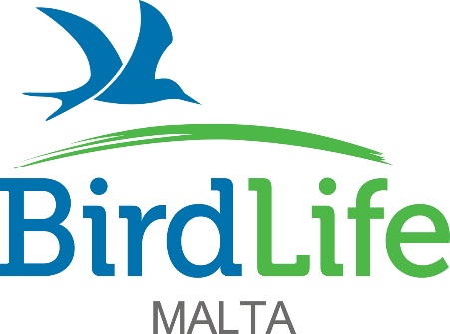

**European Solidarity Corps 2025**

*New voluntary positions covering accommodation, expenses and allowance*

We are looking for new full-time volunteers to join our international team protecting birds and their habitats and inspiring and educating people about birds and nature in the Maltese Islands. Volunteers will be based in our offices and at our nature reserves in Malta. Those who have previously participated in a long-term Erasmus+ European Voluntary Service (EVS) scheme or long-term Erasmus+ Volunteering scheme are not eligible to apply for these positions.

**Are you:**

* Aged 18-30
* A citizen of one of the[programme or partner countries](https://europa.eu/youth/solidarity/countries-covered_en)
* Outgoing, friendly, keen to meet new people, socialise, and experience a different culture
* Interested in improving bird, flora and other taxa identification skills
* Interested in inspiring and educating people about birds and the natural world
* Willing to develop administration, time management, numeracy, and interpersonal skills
* Willing to learn and having an adaptable approach in line with the needs of a charitable organisation’s structure including working flexible and occasional long hours, which could include weekends and public holidays.

**The European Solidarity Corps programme will provide you:**

* Accommodation close to our offices in Ta’ Xbiex/in the northern part of the island close to our nature reserves, or with host families
* Utilities such as electricity, water, gas, and internet
* Reimbursement of the flight and other transport costs (bus, train, metro) to/from Malta, limited according to distance
* €380 monthly allowance
* Private HEALTH insurance provided by Henner

**Public Engagement (1 position)**

**Position**: Film Production & Photography Assistant (1 position)

**Dates**: July 2025 – May 2026 (10 Months)

The Film Production & Photography Assistant will assist in raising the profile of the organisation and its work through a variety of activities. Applicants are expected to have an interest in nature and the environment. The chosen applicant should have a good command of English. Knowledge of CapCut, Adobe Premiere and Photoshop is a must. Knowledge of InDesign and Illustrator is an asset. The volunteer will assist the Design & Digital Media Officer and will report directly to the Public Engagement Executive, fulfilling the following duties:

* Attend public and press events as a photographer/videographer
* Edit photographs using Photoshop to be used in internal and external

communication

* Produce and edit high quality video content for local and international audiences using CapCut and Adobe Premiere Pro
* Play a key role in BirdLife Malta’s migration camps (Spring Watch and Raptor Camp) by downloading and organising photos and footage from the conservation team and creating videos to distribute to the media
* Manage video uploads and social media channels
* Archive, organise and upload multimedia content to the digital media library
* Assist in the design of BirdLife Malta’s printed materials including promotional leaflets, banners, magazines, logos and educational materials
* Assist in the design and production of graphics and visuals for website, social media and advertising.

|  |
| --- |
| **TO APPLY** |

Please download and fill in the [**application form**](https://birdlifemalta.org/wp-content/uploads/2025/06/ESC-Film-Production-Assistant-Application-form-2025.docx), and send it together with your CV and, if available, a portfolio showcasing your film and photography work by email to [**antonia.micallef@birdlifemalta.org**](mailto:info@birdlifemalta.org)with subject: **Application for ESC (Film Production & Photography Assistant).**

We highly recommend that you visit our website on [www.birdlifemalta.org](http://www.birdlifemalta.org) for further information before applying.

**Applications close on Monday 7th July 2025 at noon.** Teams/Zoom interviews will take place shortly afterwards. **Please note that incomplete and/or late applications will not be taken into consideration.**