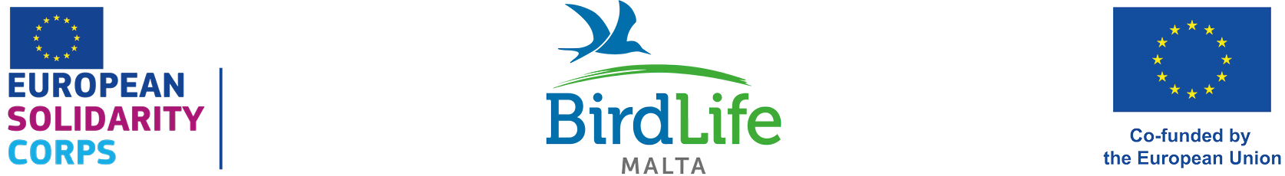

European Solidarity Corps vacancy
Application Details

Voluntary position covering accommodation, expenses and allowance

Dates: 1st July 2025 – 30thApril 2026 (10 months)

Number of positions (1):
- Events and outreach assistant

We are looking for a new full-time volunteer to join our international team protecting birds and their habitats and inspiring and educating people about birds and nature in the Maltese Islands. The volunteer will be based in our office and at our nature reserves in Malta. Those who have previously participated in a long-term Erasmus+ European Voluntary Service (EVS) scheme or long-term Erasmus+ Volunteering scheme are not eligible to apply for this position.

Are you:

- Aged 18-30
- A citizen of one of the programme or partner countries
- Outgoing, friendly, keen to meet new people, socialise, and experience a different culture
- Interested in improving bird, flora and other taxa identification skills
- Interested in inspiring and educating people about birds and the natural world
- Willing to develop administration, time management, numeracy, and interpersonal skills
- Willing to learn and having an adaptable approach in line with the needs of a charitable organisation’s structure including working flexible and occasional long hours, which could include weekends and public holidays.

The European Solidarity Corps programme will provide you:

- Accommodation close to our offices in Ta’ Xbiex/in the northern part of the island close to our nature reserves, or with host families
- Utilities such as electricity, water, gas, and internet
- Reimbursement of the flight and other transport costs (bus, train, metro) to/from Malta, limited according to distance
- €380 monthly allowance
- Private HEALTH insurance provided by Henner

Description of duties:

Events and Outreach Assistant (1)

BirdLife Malta is looking for an engaging and enthusiastic person to inspire, involve and educate children, young people and adults about birds and the natural world. As an Events & Outreach Assistant you will be involved in planning, delivering and running and promoting events, delivering schools visits, assisting the Education and Communication team.

We are looking for motivated individuals with the following profile:
- Good command of English
- A passion for the natural environment
- Good communication and engaging skills
- Ability to enthuse, lead and inspire others to appreciate the natural environment
- A background in environmental education, biology, communication, equivalent studies or equivalent experience will be considered an asset
- Experience with delivering nature sessions for different age groups will also be considered an advantage
- Flexibility to work during weekends

The chosen candidate will fulfil a combination of the following tasks:

Events
- Organise and coordinate a calendar of events, handling booking procedures, managing events emails, and keeping an accurate record of all events
- Assist the Public Engagement team, and other relevant BirdLife Malta committees and sub-committees with the organisation of events
- Prepar communications materials to promote these events
- Promote events on BirdLife Malta’s website and social media, newsletter and magazine
- Promote memberships and engagement with BirdLife Malta at stalls, fairs, events and in other public places
- Compile statistics for events which include numbers of participants, costs and donations
- Support the Events and Volunteers Coordinator with recruiting and training volunteers to assist with events and conservation work
- Support Event and Activities Committee
- Write blogs, articles, social media posts and newsletters about events and outreach work delivered

Education and outreach
- Deliver school educational sessions at the Nature Reserves for Early Years
- Deliver schools talks
- Participate in stands to promote BirdLife Malta’s work
- Engage with the community
- Collaborate with Education Assistants to deliver a programme of events and activities targeting families, young people and the local community
- Coordinate BirdLife Malta’s FALKO youth group and create opportunities for youths
- Design engagement activities

Administration and office communication
- Attend regular meetings with the Public Engagement team to review progress and plan ahead
- Compile an end-of-year report for volunteering assistants
- Support the Events and Volunteers Coordinator with any additional administration tasks when requested
- Booking school field visits at nature reserves

TO APPLY

Please download and fill in the application form and return in PDF format to education@birdlifemalta.org with subject: Application for (European Solidarity Corps) Events and Outreach Assistant. Please note that CVs without the application form filled in will not be considered.

We highly recommend that you visit our website on www.birdlifemalta.org for further information before applying.

Applications close on Monday 14th April 2025 at noon. Zoom/Skype interviews will take place shortly afterwards. Only shortlisted candidates will be contacted. Please note that incomplete and/or late applications will not be taken into consideration.

