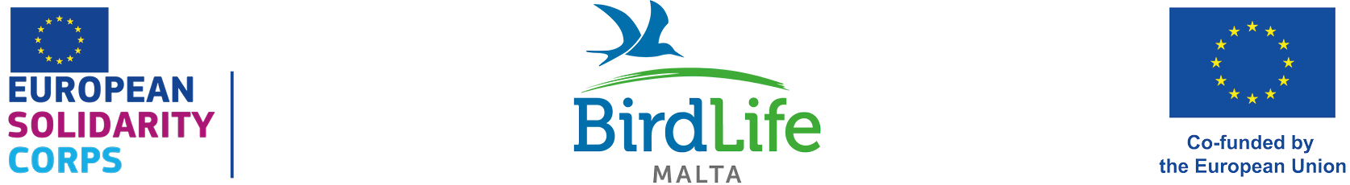

European Solidarity Corps vacancy
Application Details

Voluntary position covering accommodation, expenses and allowance

Dates: July 2025 – April 2026 (10 months)

Number of positions (1):
- Education Assistant

We are looking for a new full-time volunteer to join our international team protecting birds and their habitats and inspiring and educating people about birds and nature in the Maltese Islands. The volunteer will be based in our office and at our nature reserves in Malta. Those who have previously participated in a long-term Erasmus+ European Voluntary Service (EVS) scheme or long-term Erasmus+ Volunteering scheme are not eligible to apply for this position.

Are you:

- Aged 18-30
- A citizen of one of the programme or partner countries
- Outgoing, friendly, keen to meet new people, socialise, and experience a different culture
- Interested in improving bird, flora and other taxa identification skills
- Interested in inspiring and educating people about birds and the natural world
- Willing to develop administration, time management, numeracy, and interpersonal skills
- Willing to learn and having an adaptable approach in line with the needs of a charitable organisation’s structure including working flexible and occasional long hours, which could include weekends and public holidays.

The European Solidarity Corps programme will provide you:

- Accommodation close to our offices in Ta’ Xbiex/in the northern part of the island close to our nature reserves, or with host families
- Utilities such as electricity, water, gas, and internet
- Reimbursement of the flight and other transport costs (bus, train, metro) to/from Malta, limited according to distance
- €380 monthly allowance
- Private HEALTH insurance provided by Henner

Description of duties:

EDUCATION ASSISTANT (1)

The education team is looking for engaging and enthusiastic people to inspire, involve and educate children, young people and adults about birds and the natural environment.

We are looking for motivated individuals with the following profile:
- Good command of English
- A passion for the natural environment
- Good communication and engaging skills
- Ability to enthuse, lead and inspire others to appreciate the natural environment
- A background in environmental education, biology, communication, equivalent studies or equivalent experience will be considered an asset
- Experience with delivering nature sessions for different age groups will also be considered an advantage
- Flexibility to work during weekends

The chosen candidate will fulfil a combination of the following tasks:

School education:
- Delivering educational talks and activities in Primary and Secondary schools
- Delivering nature sessions for early years and Year 6 classes at Salina Nature Reserve
- Encouraging and training teachers to carry out nature-based learning
- Supporting with the delivery of teacher training workshops
- Supporting with the creation of wildlife gardens in schools
- Monitoring and evaluating the schools’ engagement with our Dinja Waħda environmental education programme
- Booking school field visits at our nature reserves
- Compiling newsletters for schools

Outreach and engagement:
- Creating activities, resources and events for engaging children of different ages with nature
- Leading outreach and community events
- Participating at stands and fairs
- Developing Klabb Ħuttaf (children) membership events
- Assisting BirdLife Malta’s Nature Guardians seasonal courses
- Delivering summer course sessions
- Coordinating sessions with youths, scouts and guides, Systems of Knowledge students
- Engaging with the public at BirdLife Malta’s nature reserves
- Supporting our Erasmus+ international projects’ deliverables and events
- Creating content for BirdLife Malta social media
- Coordinating with FALKO youth group

Administration and office communication:
- Attending regular meetings with the education team
- Compiling an end-of-year handover report
- Keeping up-to-date engagement data
- Supporting the education team with any additional administration tasks
- Writing of blogs, articles, social media posts and monthly newsletters

TO APPLY

Please download and fill in the application form and return in PDF format to education@birdlifemalta.org with subject: Application for (European Solidarity Corps) Education Assistant. Please note that CVs without the application form filled in will not be considered.

We highly recommend that you visit our website on www.birdlifemalta.org for further information before applying.

Applications close on Monday 14th April 2025 at noon. Zoom/Skype interviews will take place shortly afterwards. Only shortlisted candidates will be contacted. Please note that incomplete and/or late applications will not be taken into consideration.

