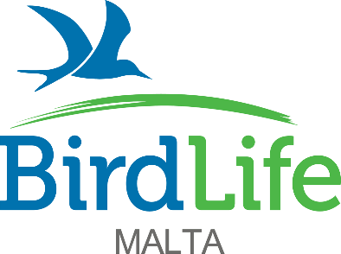

Application form for EUROPEAN SOLIDARITY CORPS volunteering
Closing date Thursday 15th June, 2023

Personal details
Name and surname: ________________________________________________________
Date of birth: _ _/_ _ /_ _ _ _
(Applicant’s age must be between 18 and 30 on commencement of volunteering term)
Nationality ________________________________________________________
Address: ________________________________________________________
Postcode________________ Country _________________________
Email ________________________________
Phone number ________________________________
PASS registration number Youth Portal registration ________________________
I confirm that I am a citizen of a programme and partner countries YES/NO

Role applying for:
Please mark in order of preference, 1 being your first choice
Education Assistant
Events and Outreach Assistant

Tell us about yourself
Are you available to do the full term of 12 months? _____________
If you are currently working, how long is the notice period? _____________
If you are studying, when are you available to start? _____________
Do you hold a valid driving licence? _____________
Do you have a valid first aid course? _____________
Are you willing to share a room if necessary? _____________
Have you lived in shared accommodation before (other than your home) _____________

Education and Professional Training
Please begin with most recently attended and add/expand the boxes as necessary.
Place and year of study | Main area of study/Faculty | Qualifications

Employment History
Please begin with details of your most recent employers and add/expand the boxes as necessary.
Employer | Job title | Start date – end date | Key responsibilities | Employment/Internship/volunteering position?

Language Skills
ESC offers OLS – Online Linguistic Support however we would like to know how you fare in languages. Please indicate level according to CEFR -global scale
Beginners level A1, A2; Intermediate level B1, B2; Advanced level C1, C2
1._______________________ level ____________
2._______________________ level ____________
3._______________________ level ___________
Please tell us about yourself and why you are applying for this role. What do you wish to gain from this experience?

Please, tell us what are your strengths and skills that make you a suitable candidate for this role

This application form is to be returned to BirdLife Malta at the email address education@birdlifemalta.org. For certain roles a recent Police Conduct may be required.

Thank you for your application!
Please note that shortlisting will commence after closing date and shortlisted applicants will be contacted for an interview.

The information contained in this application form will be used solely for the purpose of European Solidarity Corps recruitment for the duration of this project and will not be retained further, in accordance with GDPR Regulations.

