FOR BIRDLIFE MALTA
USE ONLY
ACKNOWLEDGE
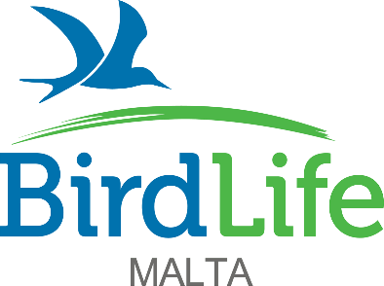

57/28, Abate Rigord Street, Ta’ Xbiex XBX1120, Malta
info@birdlifemalta.org www.birdlifemalta.org

APPLICATION FOR POST OF

NATURE RESERVES

ASSISTANT MANAGING WARDEN

(full-time)

Closing date Wednesday 8th June 2022 at 10:00

STRICTLY CONFIDENTIAL
THE INFORMATION CONTAINED IN THIS APPLICATION FORM WILL BE USED SOLELY FOR THE PURPOSE OF THE EMPLOYMENT OF THE ABOVE MENTIONED POST AND UNLESS OTHERWISE REQUESTED BY THE APPLICANT, WILL BE RETAINED BY BIRDLIFE MALTA FOR STAFF RECRUITMENT PURPOSES IN THE EVENT OF ANY ADDITIONAL FUTURE VACANCIES.

This application form is to be returned as a PDF to BirdLife Malta at the email address mark.gauci@birdlifemalta.org with subject ‘Application for Post of Nature Reserves Assistant Managing Warden (full-time)’ along with a short cover letter/email by Wednesday 8th June 2022. Please attach a CV with your email. Interviews will take place in person or over MS Teams in the weeks that follow.

How did you learn of this vacancy?

Personal details
(Boxes expand automatically as you type.)

Surname |  | Dr/Mr/Mrs/Miss/Ms/Other

Forename(s)

Address

Postcode

Contact Tel no |  | Other Tel no

Nationality

May we, with discretion, phone you at work? Yes No
Why are you interested in this role?
Do you hold a full driving licence? Yes No
If yes, please give details below and the year of issue and state if you are a regular driver or otherwise

Do you hold a bird ringing licence? Yes No
If yes, please give details below and the year of issue including any endorsements

Do you hold a Maltese residency/ID card? Yes No

Have you received training in administering First Aid/Rescue? Yes No
If yes, please give details below and the year of issue

Qualifications
List the qualifications you have taken or are about to take.

Type of qualification | Subject | Result/date | Type of qualification | Subject | Result/date

Language skills

Language:

Mother tongue | Fluent | Intermediate | Basic

Language:

Mother tongue | Fluent | Intermediate | Basic

Language:

Mother tongue | Fluent | Intermediate | Basic

Present or last employer/volunteer role details
Company name and address

Postcode

Position held

Dates from |  | To

Final or most recent salary and benefits

Outline present duties

Reasons for wishing to leave your present role

Do you need to provide a notice period to your current employer? Yes No
If yes, please indicate length of notice required

Past employment/volunteering details (Excluding your present or last employment)
Employer’s name & address | Job title | Date |  | Salary | Reasons for leaving
 |  | From | To

Relevant experience
Please use the role description to indicate where you have relevant skills and experience to the role you are applying for.

Publications or work of note
Detail below any publications of reports you have authored which might be of relevance to the required role indicating whether you have been the principal author or co-author.

Conferences and workshops
Detail below any conferences or workshops you have attended or presented at which might be of relevance to the required role indicating whether you have been the principal author or co-author.

Training courses
Detail below any specialised training you have received, or any relevant short courses attended. Use of geographical information systems and statistical software will be considered as assets.

Spare time interests and vocational activities

Criminal record
Have you ever been prosecuted or convicted in connection with any offence and is there any pending prosecution? Yes No

If yes, please give details

Declaration
I confirm that the information contained in this application form is correct.

Signature

Date

