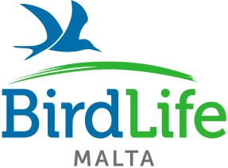

Warden for a day

Name: ___________________________________________________________________________
Address: __________________________________________________________________________
_________________________________________________________________________________
Tel No (Including area code): ________________________ Date of birth: ______________________

Medical/Special Requirements
Please circle either Yes or No
Do you have any disabilities, conditions, allergies, special needs or cultural needs that might affect this event? Yes/No
If so, please list below.
____________________________________________________________________________________________________________________________________________________________________
Are you taking any Medication? Yes/No
If so, please list the medication you are currently using.
____________________________________________________________________________________________________________________________________________________________________
Do you have any dietary requirements? Yes/No
If so, please explain below.
____________________________________________________________________________________________________________________________________________________________________

Emergency Contact Details
Name: ____________________________________________________________________________
Relationship to participant: ___________________________________________________________
Address: __________________________________________________________________________
__________________________________________________________________________________
Tel No (Including area code): ________________________
Email Address: ___________________________________________________
Photographic consent

I give/ do not give permission to be photographed during BirdLife Malta Warden for a day. I also give permission for my name to be used with any photographs taken.

I understand the photographs taken may be published by the media and may also be used by the BirdLife Malta for a range of promotional purposes in the future. They will also be held on file by BirdLife Malta.

Data Protection Statement
This information will be securely held by the BirdLife Malta Activity leader, and will be used for group purposes only. Details will not be sold or given to any third party. Please ensure that the activity leader is informed of any changes to this information.
While I appreciate that every attention will be given to personal safety, in the event of an accident, I permit the activity leader to authorise any medical treatment, which he/she believes necessary.
Participant signature
Signed __________________________________ Date ________________________________
Parental consent
Signed __________________________________ Date ________________________________

